

DDL Scale Reduction System
Scale and Hardness Protection with Template Assisted Crystallization

Introduction
For years, water softeners have been virtually the only means of treating hard water. Other alternatives including magnets, electromagnets, RF devices and catalysts have been available but haven’t proved to be effective.
Technology Breakthrough
A recent development, Template Assisted Crystallization (TAC) has produced the first effective chemical-free scale prevention method. Based on TAC technology, WFM SR converts hardness minerals into harmless, inactive microscopic crystals.
Tested and Proven
Tested by an independent laboratory against the international protocol for scale prevention, WFM SR achieved up to a 99.6% effectiveness rating – the only technology to do so and far more effective than any other water softener alternative. Proven in over 6 years of successful use in homes and businesses.
Benefits
- Protection from lime scale throughout the house.
- No salt, chemicals or electricity required.
- Long lasting filter media.
- Preserves beneficial mineral content
- No slimy soft water feel
Features
- Extremely efficient - 5 seconds contact time regardless of hardness level. Conventional Ion Exchange resin requires 90 seconds.
- No salt or other chemical reagents required.
- No backwash waste. Can be used in areas where water softeners are banned. Protects the environment and reduces water usage.
- No control valve or electricity required.
- Media can be used in either conventional mineral tanks or POU cartridge form.
- Media operates in up flow condition.
Crystal Formation
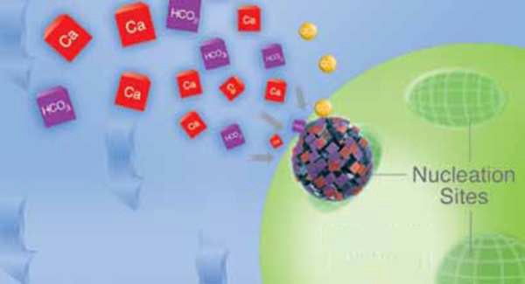
Atomic sized nucleation sites on the surface of small polymer beads convert dissolved hardness into microscopic crystals.

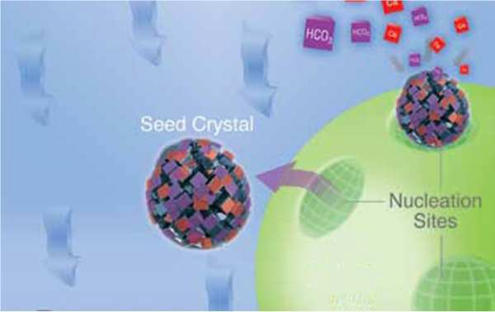
Once the crystals grow to a certain size they are released from the bead. The crystals in solution keep the hardness out of the water so that it can’t form scale or interfere with soap.

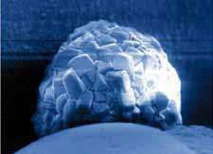
Crystal photo taken with a Scanning Electron Microscope

PROTECT YOUR DENTAL PRACTICE FROM EXTREME HARD WATER

WFM SR System
Water Chemistry & Limitations
- pH 6.5 to 8.5
- Hardness, max. 75 grains (1300 ppm CaCO3)
- Temperature 41 to 140° F (5-60° C)
- Chlorine <3ppm
- Iron 0.3 mg/l
- Manganese 0.05 mg/l

- Copper 1.3 mg/l*
- Oil & H2S Remove prior to WFM SR system.
- Polyphosphates Remove prior to WFM SR system
*If fitting the system at the same time as new copper pipe work the unit must be bypassed for the first 3 weeks as copper levels in the water may exceed 1.3 mg/l

Regulatory Approvals

Scale Prevention filter media is WRAS Approved, and certified to NSF/ANSI Standard 61
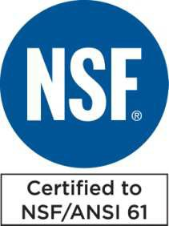
Applications
WFM SR system has proven itself in a variety of applications as an alternative to ion exchange softening or other conventional water treatment methods. The maintenance-free characteristics make it especially suited for Foodservice and Commercial applications where equipment maintenance is often overlooked.
Foodservice
- Coffee & Tea Brewers • Espresso Machines
- Boiler based Steamers • Proofer Ovens
- Steam Tables • Mist Cooling Systems
Commercial/Industrial
- Car Washes • Evaporative Cooling
- Dental:Reverse Osmosis
•Residential
- Water Heater • Laundry
- Dishwasher • Bath and Shower

Note: In some properties a slight bloom may be seen on shower screens/sinks where water has evaporated, this residue is just minerals which have been prevented from bonding to form scale. This is easily removed by a soft cloth.
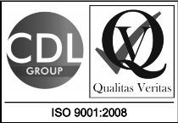
Depending upon water composition some models of kettles may still overtime form a hard crust inside; this is aragonite/silica and occurs as the kettle is poured nucleation points on the heating element flash burn off the remaining moisture and leave mineral deposits behind - this is not lime-scale.

Dental Decontamination Limited - Tel 01253 736355
-www.DentalDecontamination .co.uk

