

Installation, Operation & Maintenance Guide for the DDL3 HT+ Dental & Lab Direct Flow Reverse Osmosis System
Contact:
Dental Decontamination Limited.
17,Alexandria Drive ,Lytham St.Annes FY8 1JF
Tel: (01253) 736355
Email:Account@Dentaldecontamination.co.uk

The DDL3 HT+ Reverse Osmosis System is designed to meet the needs of your Dental Practice or Laboratory.
DDL3 HT+ primary uses are:

- Use in autoclave
- Use in DUWL
- Rinsing of instruments during manual cleaning
- Holding of instruments prior to decontamination
- Use in rise cycle of washer disinfectors.

Installation Precautions

- This, and any other pressurised system connected to the water mains, or pumped from a tank or gravity fed, should be protected as appropriate from leaks. It is necessary to ensure that the property where this system will be installed has controlled pressure regulation using a Pressure Reducing Valve to ensure the maximum pressure cannot go above the specified parameters. You are also advised to use a leak detector, such that if any leak is detected, the supply to the system will shut off and not cause damage due to water leaking to the property. This is especially important as water [pressure can rise on the evenings and weekends to over double what you measure in the daytime.

- , Please use clean vinyl gloves when handling the filters and touching then. This is avoid any bacterial contamination from your hands to the filters which can then multiply and cause a bad smell in the system.

- Introduction

The DDL3 HT+ Dental & Lab Direct Flow Reverse Osmosis System has been designed and built specifically for dental surgery and laboratory applications where near to 0 TDS water is required. This model replaces the DDL3System which was a tank based reverse osmosis system. Being direct flow, the DDL3 HT+ Dental & Lab Direct Flow Reverse Osmosis System does not use a tank, but instead has a larger pump and membrane so it can provide a direct flow of water. This offers massive advantages:
- No need to sanitise a tank.
- Huge saving in the amount of water going to drain…calculated at a 50% saving against other systems.
- Overall less costs in bills and improved sanitary condition of the system - all leading to a
much more reliable and efficient operation.

- Product Features

Produce deionised water at a small fraction of the cost of water distillers right in your own facility.
- Ideal for autoclaves / sterilizers
- Will Remove up to 99.99% of impurities from UK mains water.
- Under the counter commercial system that generates DI water.
- Plug & Play parts for easy maintenance.
- Meets HTM requirements: 0-3 ppm (TDS) DI water (DI quality)
- Analyses water, tracks filter lifetime and optimizes performance
- Standing model, no need to mount to wall
- Small footprint for easy installation and service
- 6 Month pre-filter change lifetime
- DI filter change lifetime when TDS changes (1-6 months)
- RO Membrane filter change lifetime when TDS changes (18-24 months)
- Full, courteous support provided by experienced professionals

DDL3 HT+ is the perfect solution for Dental Practices and other facilities that require on-de- mand deionized water. The system comes complete tap and installation kit. HT+ is a digitally controlled reverse osmosis system with Smart Water capability that is specifically designed for dental and medical applications where deionized water is required. The system incorporates high quality filters, easy Plug & Play components and a digital controller which tracks filter lifetime as well as measure instantaneous water purity. After the reverse osmosis process, the DDL3 HT+ system is equipped with a high quality mixed bed filter which purifies the water down to deionized levels.

Technical Specifications

Electricity 100 - 240 VAC / 50-60 Hz
Feed Water Pressure 2 Bar Min. - 6 Bar Max. Please use a pressure reducer if feed water pres- sure is above 6 bar.
Feed Water Temperature 4 - 40°C Feed Water Connection 1/2" NPT
System Dimensions 48cm Height x 36cm Width x 24cm Depth System Weight 12 KG

Feed Water Specifications

For the conditions below, the system will produce 60 litres of DI water per hour. Please ensure you contact Osmio Water team if your feed water does not meet these levels. Ensure that water going into the system is micro-biologically safe. If you are on a private supply, ensure there is proper UV treatment to the water before it supplies the Osmio HT+.
pH 6.5 - 8.5
Turbidity < 5 NTU TDS < 1000 PPM
Hardness < 500 PPM CaCO3 (50°F) (28°dH)
Chloride < 250 PPM Free Chlorine < 0.7 PPM Iron < 0.1 PPM
Manganese < 0.1 PPM Silica < 0.1 PPM
Chemical Oxygen Demand < 5 PPM O2 Total Bacteria Count < 50 CFU / mL
E. Coli < 3 CFU

- DDL3 HT+ Filters

- 5 Micron Sediment Filter - For particles and dust to 5 micron.
- recommended change every 6 months

- GAC Carbon Filter - For chlorine and chemical parameters
- recommended change every 6 months

- CTO Carbon Block - All of the above + fine particles, heavy metals such as iron,
manganese and other rust
- recommended change every 6 months

- ONE of two 400 GPD Reverse Osmosis Membrane - Dissolved solids, chemicals, micro-organisms, nano sized suspended solids, much more
- recommended change every 12-18 months

- Mixed Bed Deionized Water Filter - This filter polishes off any remaining TDS left after the
membrane. The Reverse Osmosis Membrane is normally reducing incoming TDS level by
94-98% so if the incoming TDS was 200ppm, the result after the RO Membrane should be at least 12ppm. The DI resin filter then polishes off the remaining TDS.
- recommended change depending on your requirements or autoclave (e.g. <4ppm or
<40ppm autoclaves will make a difference how often this filter will need changing. The DI Resin filter can be upgraded to a larger size filter if the frequency of change is more than every 3 months.


- Connection Schematic

There are 3 connections that have to be made, and they are made using simple push fittings:

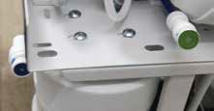
The Incoming water
1

To the Tap
2

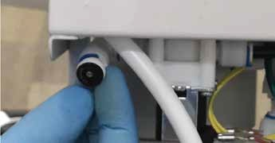
To the Drain (this is on the backside of the system)
3
3

How to Use Quick Connect Fittings

Quick connect fittings (push fittings) are used in a wide variety of plumbing, heating, electrical and fire suppression systems. Quick connect works by inserting the tubing into a connection mechanism that deploys fastening teeth onto the tubing surface. When opposing force is applied to the union, the teeth are forced deeper into the tubing, preventing separation of the union. The advantages of using quick connect fittings are:
- They offer a signiicant time saving beneit over traditional connectors
- They tend to have less user failures compared to traditional connectors
- They require little skill or strength for their usage
- They do not require any tools to use and maintain them.

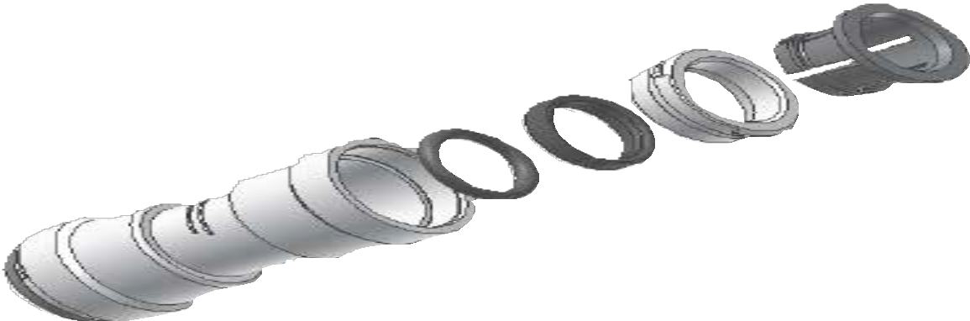
Body
Collet
Cap
O-Ring Guide

O-Ring

Exploded Diagram of a Quick Connect Fitting

All DDL3 HT+RO systems take advantage of quick connect fittings. To make a connection, the tubing is simply pushed into the fitting. The unique locking system holds the tubing firmly in place without deforming it or restricting flow. Use the steps in the figure on the next page in reference to quick connect tubing connections for this system.

Step 1: It is essential that the outside diameter of the tubing being inserted into the fitting is completely free of scratch marks, dirt and any other material. Inspect the outside of the tubing carefully.

Step 2: It is also very important that the sliced edge of the tubinGg is
Cut cleanly. If the tubing needs to be cut, use a sharp knife or scissors. Make sure to remove all burrs or sharp edges before inserting the tubing into the fitting.
Step 3: The fitting grips the tubing before it seals. Lightly push the tubing into the fitting until the grip is felt.
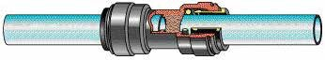

Step 4: Now push the tubing into the fitting harder until the tube stop is felt. The collet has stainless steel teeth which hold the tubing in position while the O-ring provides a permanent leak proof seal.
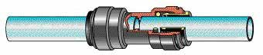
Step 5: Pull on the tubing away from the fitting and make sure it is stays firmly in place. It is good practice to test the connection with pressurized water before finishing installation.
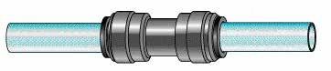
Step 6: To disconnect the tubing from the fitting, ensure that the system is depressurized first. Push in the collet squarely against
the face of the fitting. With the collet held in this position, the tubing can be removed by pulling. The fitting and tubing can be reused.
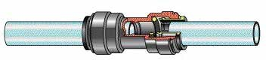
Push In Collet
Pull Tubing

How to Use Quick Connect Fittings

- Planning the Installation
Carried out by Dental Decontamination Limited engineers following the services and waste being in place.

- Installation Step 1: Feed Water Connection

The purpose of the feed water connection is to feed the system with water to be purified by tapping the cold water supply which is usually located under the kitchen counter. It has 1/2" male and 1/2" female and a tee off. The easiest place to fit it would be where the cold hose is connected to the pipework, just remove the hose and the feed in valve goers there to tee off water to the system.
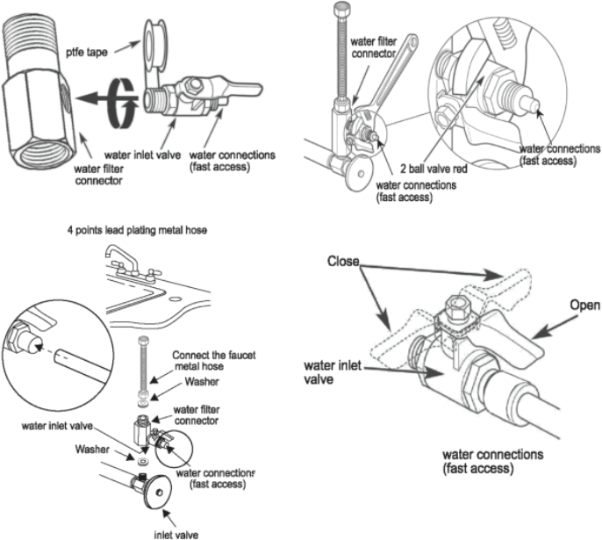

Alternatively place a ¾” BSP T piece on the mains water feed.
Dental Decontamination Limited will install the WRAS Approved double check none return valve.

Installation Step 2: Drain arrangement.

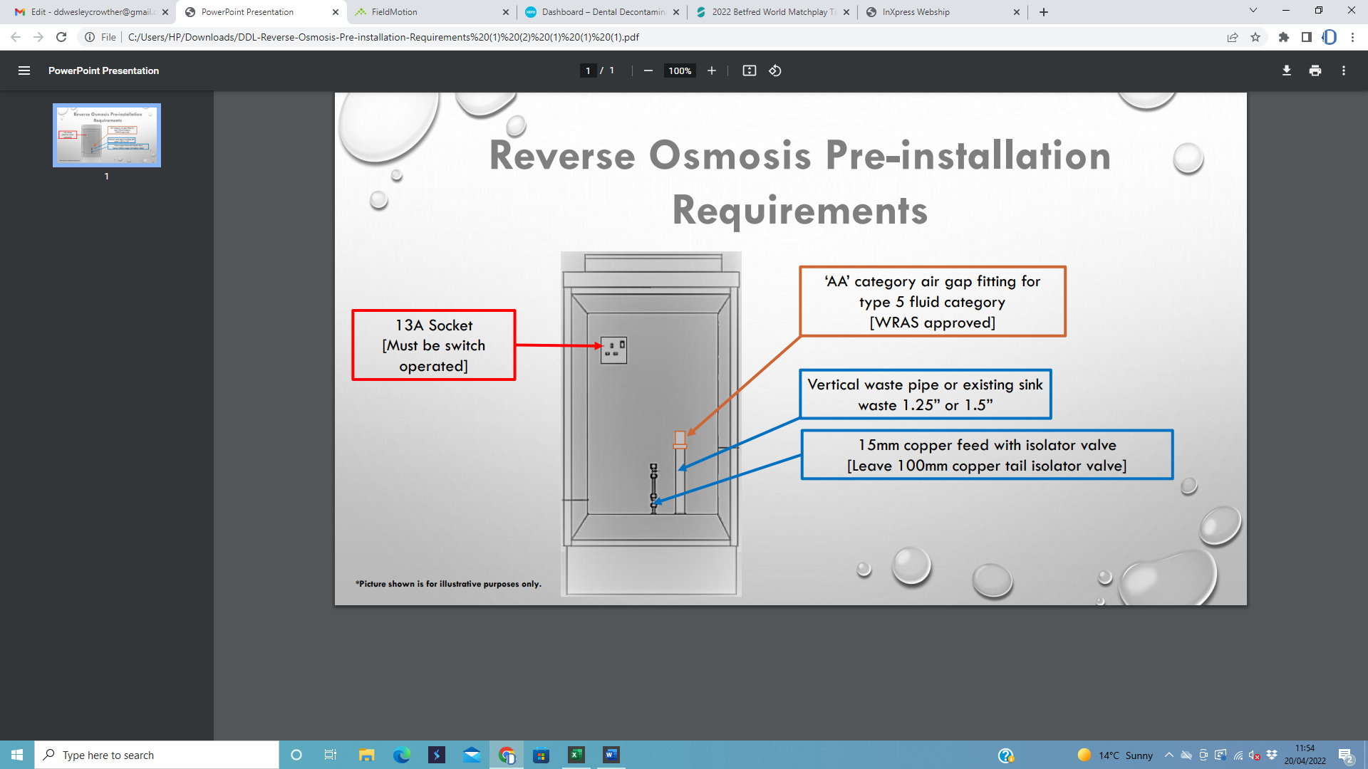

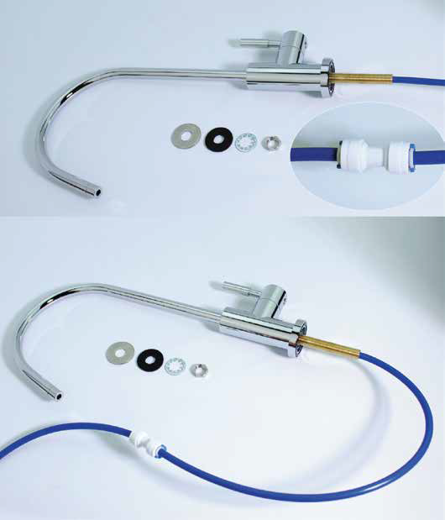
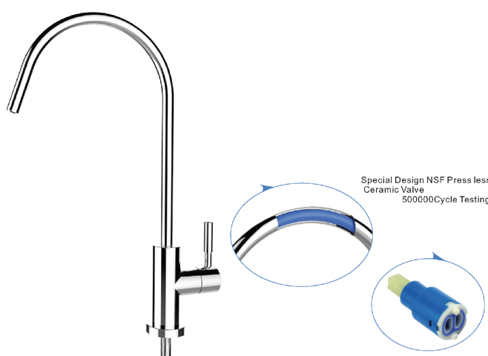
- Installation Step 3: Installing the Tap

Your DDL3 HT+ comes with a high quality chrome plated tap which we have made even easier to fit. All you need to do is drill a hole 12mm in your sink or worktop, put the tap in place and tighten it with your spanner. If you are needing to drill granite, marble or any other solid worktop, please see profes- sional advice about how to do this if you have not done it before. Once your hole is drilled, apply the parts as shown below to the base to fix the tap in place, ending with the nut on the right. The tubing from the system is then connected using the 1/4" push fit union piece provide in your kit.

NSF Certiied and LEAD-FREE
Bacteria resistant coating inside the tap

Ceramic Cartridge for years of trouble-free service

- Installation Step 4: Membrane & Filters Installation

Before handling the Reverse Osmosis Membrane, it is important that you wear sanitary gloves. This is because if you touch the membrane by hand, you will immediately put bacteria which will start a new family inside your mem- brane housing and eventually foul your membrane. When bacteria gets into the sheets of the membrane and starts growing, it will open those sheets and the TDS will increase.

1) Remove Blue Clip 2) Remove Push Fitting
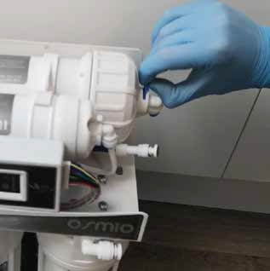
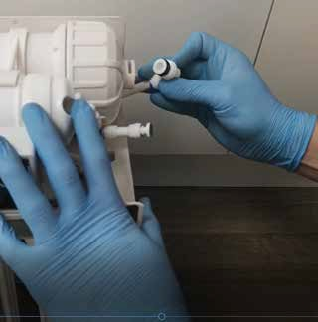

- Unscrew Membrane Cap 4) Insert Membrane
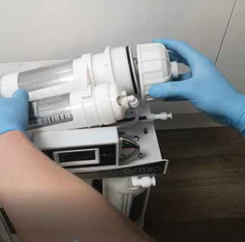
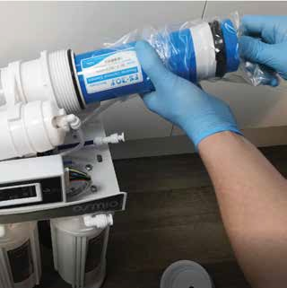

Use the membrane spanner wrench provided in your kit to loosen it if you need to
Insert the membrane into the mem- brane housing. Ensure it goes into the socket at the other end of the housing inside it and the membrane is flush with the top of the housing.

  - Screw Membrane Housing Lid Back On
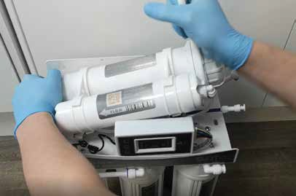
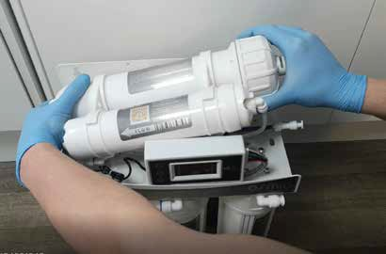

Insert the membrane into the membrane housing. Ensure it goes into the socket at the other end of the housing inside it and the membrane is flush with the top of the housing.
  - Insert Push Fitting & Clip
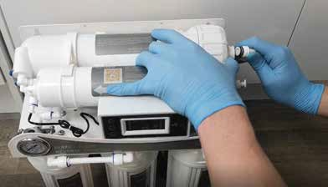
Insert the push fitting back into
the membrane housing

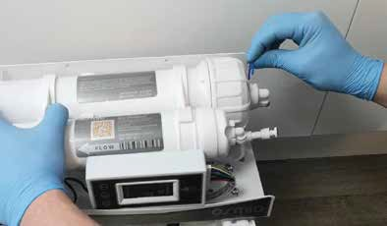
Insert the collet clip back into the push fitting

  - Install Pre Filters

The 3 pre filters are inside the bowls (IN THIER PACKAGING) so you first must unscrew the bowls and remove the filters from the bowls.


Never handle the filters by hand. Always use sterile procedures and sterile gloves. Touching them by hand can immediately compromise the hygiene of the system.

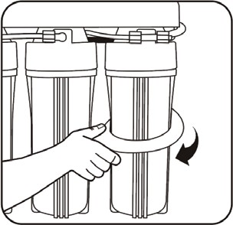
To open the bowls, use the housing spanner and turn clockwise.
Remove the pre-filters and their packaging. Place each filter back into the bowl and ensure
they are centred.

By hand then re-screw back on each bowl, ensuring first that the o-ring is both seated correctly, not damaged in any way and is greased and lubricated. If the o-rings are dry this means the bowl will not easily turn and therefore it is highly likely it will leak. In this case, ensure you grease the o-ring and each time you do a filter change.

System Start Up and Operation

Carried out by Competent Professional.

13. Filter Changes & Sanitisation Process

The system will require periodic filter changes and sanitisation. This must only be conducted by a Dental Decontamination Limited Competent Professional.
Contact Dental Decontamination Limited for more information for how to book a filter change and sanitization service.

It is vitally important for HTM & CQC decontamination room guidance, that the maintenance
of your machine only be carried out by trained professionals.

Sanitisation Process

HTM 01-05 and CQC must be implemented in your working regime and this includes sanitising your reverse osmosis system. We suggest this is carried out by a Competent professional.

- Shut off main incoming water valve at the feed in red (red lever turn it to right angle to pipe).
- Dispense water from the tap and leave tap open.
- Remove stage 1-3 filters, from filter housing
- Remove membrane, from membrane housing. If old then discard, if midterm then simply place the membrane in a sanitary bag until you are ready to put it back in.
- Remove DI Resin Filter.
- Reinstall all the filter and membrane housings without filters and membrane (remember to pour about 6-8 ounces of hydrogen peroxide in stage 1 housing)
- Reattach all connections
- Turn back on main valve.
- Let system run until some water comes out the tap. Then close the tap.
- Let it now sit for 10 minutes and then turn on the tap to flush.
- Do this at least twice until the smell of hydrogen peroxide is diluted.Use indicator strips.
- Shut off main valve again, install all new filters and membrane.
- Spray the tap spout with your sanitising solution.
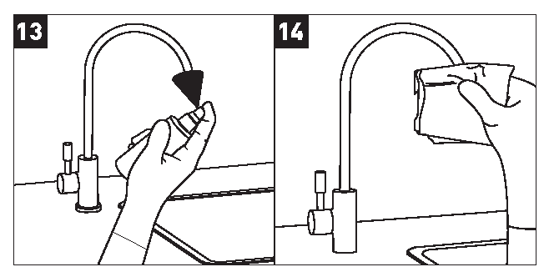
- Wipe the tap spout with a sanitary wipe or clean tissue.

Pay special attention to keeping the tap regularly clean, as
most RO systems will first get contaminated from this point.
- Turn on main valve and flush for 5 minutes.
- Your sanitisation is now complete. Next log your work on the Service Log and book in the calender the next sanitisation / filter change.

Problem | Cause | Solution
Leak between fitting and installed  part | Fitting not installed correctly | Remove the fitting, apply teflon tape  if necessary and install again
Leak between fitting and tubing | Tubing not inserted correctly | Remove and reinstall the tubing
Leak between fitting and tubing | O-ring inside fitting damaged | Replace fitting
Drain saddle leak | Drain saddle not installed properly | Reinstall the drain saddle per  Section 4.5 on page 17
Pre-filter / Membrane housing leak | O-ring seal is misaligned | Check that the o-ring is properly  aligned in the o-ring groove
Pre-filter / Membrane housing leak | O-ring is damaged | Replace the o-ring
Pre-filter / Membrane housing leak | Housing not properly tightened | Tighten the housing with the  included housing wrench
Water flows too slow from the faucet | Water supply pressure is too low | Non-pumped systems require min. 3 bar feed water pressure to operate while pumped systems require min.  2.5 bar pressure to operate. Check your supply pressure. If necessary, install a booster pump at the water main.
Water flows too slow from the faucet |  | Replace the filters
Water flows too slow from the faucet | Pre-filter or membrane filters are clogged | Replace the filters
Water flows too slow from the faucet | Tubing is kinked | Make sure no tubings to and from  the system are kinked
Water flows too slow from the faucet | The flow from the system is meant to be 0.5 litres per minute upwards | Try doing some deep abdominal  breathing and be patient and relax.
System is operating noisy | Sounds like whistle - air is stuck in  the shut-off valve | The air will go away with continued  operation
System is operating noisy | Water supply pressure is too high | Check the inlet feed water pressure, If necessary install a pressure  reducer
The system is always on (water continuously flows to drain) | Water supply pressure is too low | Check your supply pressure. If necessary, install a booster pump at  the water main.
The system is always on (water continuously flows to drain) | Pre-filter or membrane filters are  clogged | Replace the filters
The system is always on (water continuously flows to drain) | Missing or misplaced flow restrictor | Check for the location of the flow restrictor
The system is always on (water continuously flows to drain) | Shut-off valve failure | Replace the shut-off valve
The system is always on (water continuously flows to drain) | Check valve failure | Replace the check valve
"Cloudy" or "Milky" purified water. After a few seconds becomes clear again. | During first time start-up air  pressure is trapped in the system | This is normal and will pass in 3-4  days
 | If happens after weeks or months of  operation, feed water is supplied intermittently with air | This is also normal and can be  minimalized by running the system for 15-20 minutes every few weeks
Purified water has bad taste or smell | Filters are at end-of-life | Replace the filters
Purified water has bad taste or smell | Contamination in the system | Sanitize the system

Service Log Table

SERVICE LOG TABLE | Model | DDL3 HT RO

Date of Purchase | Date of Install | Installed By | Serial Number

Date | Pre-Filter + Post-Filter Change | Membrane Change | Other

After Sales
Warranty Registration
Please fill out the information below and keep for your records. Please also send a copy to www.dentaldecontamination.co.uk by simply taking a picture of it with your smart phone and mailing it to Account@Dentaldecontamination.co.uk
First Name: Last Name: Full Address: Mobile Number: Email: Date of Purchase: Date of Install: Where Purchased: Installed By: Model Number: Serial Number:

